Waves Revision

Multiple Choice

1 How do you define waves?

A Periodic oscillations that transfer energy

B Periodic oscillations that transfer matter

C Periodic oscillations that transfer both energy and matter

D Any cyclic motion; i.e. a motion that repeats itself regularly

2 Which of the following is not a mechanical wave?

A Sound

B Light

C A wave on the sea

D Seismic waves

3 How do the particles of the medium move in a transverse mechanical wave?

A Up and down, at right angles to the direction of the wave motion

B Back and forth, in the direction of the wave motion

C In the direction of the wave motion, at varying speeds

D In the direction of the wave motion, at the speed of propagation of the wave

4 How do the particles of the medium move in a longitudinal mechanical wave?

A Up and down, at right angles to the direction of the wave motion

B Back and forth, in the direction of the wave motion

C In the direction of the wave motion, at varying speeds

D Perpendicular to the wave motion, at the speed of propagation of the wave

5 Which of the following is the period of a wave?

A The time it takes before the wave repeats itself

B The number of times the wave repeats in a given time interval

C The distance from one peak or crest to the next

D The largest distance of a particle from its average position

6 Which of the following is the wavelength?

A The time it takes before the wave repeats itself

B The number of times the wave repeats in a given time interval

C The distance from one peak or crest to the next

D The largest distance of a particle from its average position

7 Which of the following is the frequency of a wave?

A The time it takes before the wave repeats itself

B The number of times the wave repeats in a given time interval

C The distance from one peak or crest to the next

D The largest distance of a particle from its average position

8 Which of the following is the amplitude of a wave?

A The time it takes before the wave repeats itself

B The number of times the wave repeats in a given time interval

C The distance from one peak or crest to the next

D The largest distance of a particle from its average position

9 The following two wave patterns representing two different sound waves appeared on an oscilloscope.

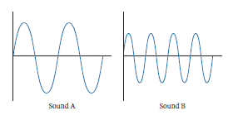

Which of the following is true?

A Sound A has a higher amplitude and a higher frequency than sound B.

B Sound A has a higher amplitude but a lower frequency than sound B.

C Sound A has a lower amplitude but a higher frequency than sound B.

D Sound A has a lower amplitude and a lower frequency than sound B.

10 Which of the following is the angle of incidence for the light ray shown?

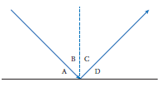

A Angle A

B Angle B

C Angle C

D Angle D

11 Which of the following is an example of diffraction?

A A ray of light hits a mirror and bounces back.

B A ray of light changes direction as it moves from air to water.

C A sound echoes from a cliff.

D A sound wave through a door bends and spreads out.

12 Two identical sounds are produced, but when they are sounded together the volume is much lower than for each individual wave. This is an example of:

A constructive interference.

B destructive interference.

C messy interference.

D a stationary wave.

13 When you blow over the top of a bottle, it starts to make a sound. This is an example of:

A resonance.

B forced vibrations.

C free vibrations.

D both A and B.

14 What is a standing or a stationary wave?

A A wave that is not moving, v = 0

B A wave that appears to be not moving

C The result of two waves moving in opposite directions

D Both B and C

15 What is ultrasound?

A Sound at a frequency too high for human hearing

B Sound at a frequency too low for human hearing

C Sound loud enough to damage the eardrums

D Both A and C

Short Answer

1 A wave with a frequency of 25 Hz is moving at 75 m s–1.

a What is its period?

b What is its wavelength?

2 An ambulance parked nearby starts sounding its siren. As it starts moving towards you the sound changes, and when it passes you the sound changes again. Explain how the sound changes and why.

3 Illustrate the following with diagrams, showing all nodes and antinodes.

a A string is vibrating at the third harmonic.

b A closed pipe is vibrating at the fifth harmonic. How is particle displacement shown?

4 In a certain hall, the speed of sound is 332 m s–1, and a 50 cm pipe is open at both ends.

a What is the fundamental wavelength?

b What is the fundamental frequency?

c What is the frequency of the fifth harmonic?

d If the upper limit of human hearing is 20 kHz, is the fifth harmonic audible?

5 Use the graph below to find:

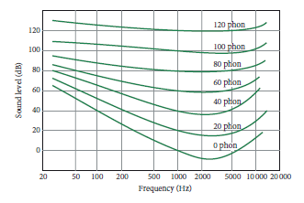

a the frequencies at which a 40 dB sound would have an apparent loudness of 40 phon.

b the range of frequencies which could be heard at 20 dB.